**Chapter-1**

**INTRODUCTION**

* 1. **Introduction to the Project**

This system helps university students to find accommodations easily and quickly. A student can search a dormitory by visiting this website. They can search the require dormitory according to location, price and status. Dormitory owner can advertise their rooms for rent on the website. It also provides error message while entering invalid data. No formal knowledge is needed for the user to use this system. Thus by this all it proves it is user-friendly.

**Chapter-2**

**Objectives of the System**

**2.1 Objectives of the System**

* To develop a student accommodation search system that allows the user to view accommodation’s data.
* To provide user the details of property and agent.
* To develop student accommodation search system via online.
* To find an accommodation that fit with your budget.

**2.2 System Specification**

**2.2.1 Software Requirements**

Operating System - Microsoft Window 10 and above

Language - HTML, CSS, PHP, MYSQL, Xampp Server

**2.2.2 Hardware Requirements**

Processor - Intel(R) Core(TM) i7-6820HQ CPU @

2.70GHz 2.70 GH

RAM - 16.0 GB

Hardisk - Support 1000GB

**2.3 Entity Relationship Diagram**

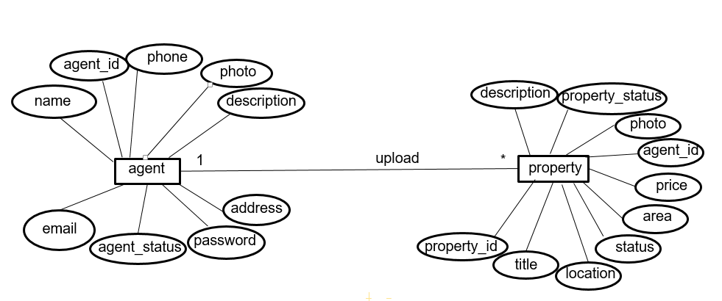

**Figure 2.3 Entity Relationship Diagram**

**Chapter-3**

**SYSTEM DESIGN**

**3.1 System Architecture**

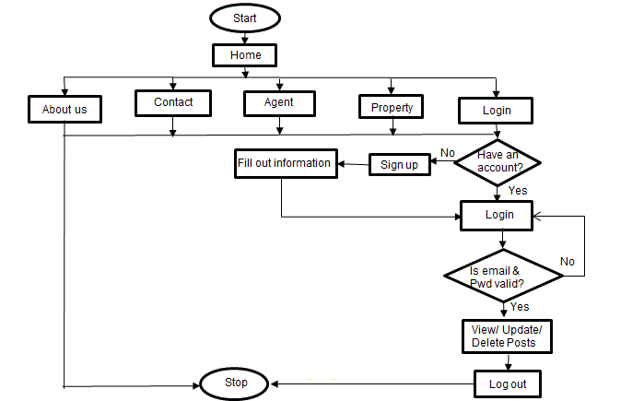

**Figure 3.1 System Architecture**

**3.2 Home Page**

Users can go About Page, Property Page, Agent Page, Login Page.

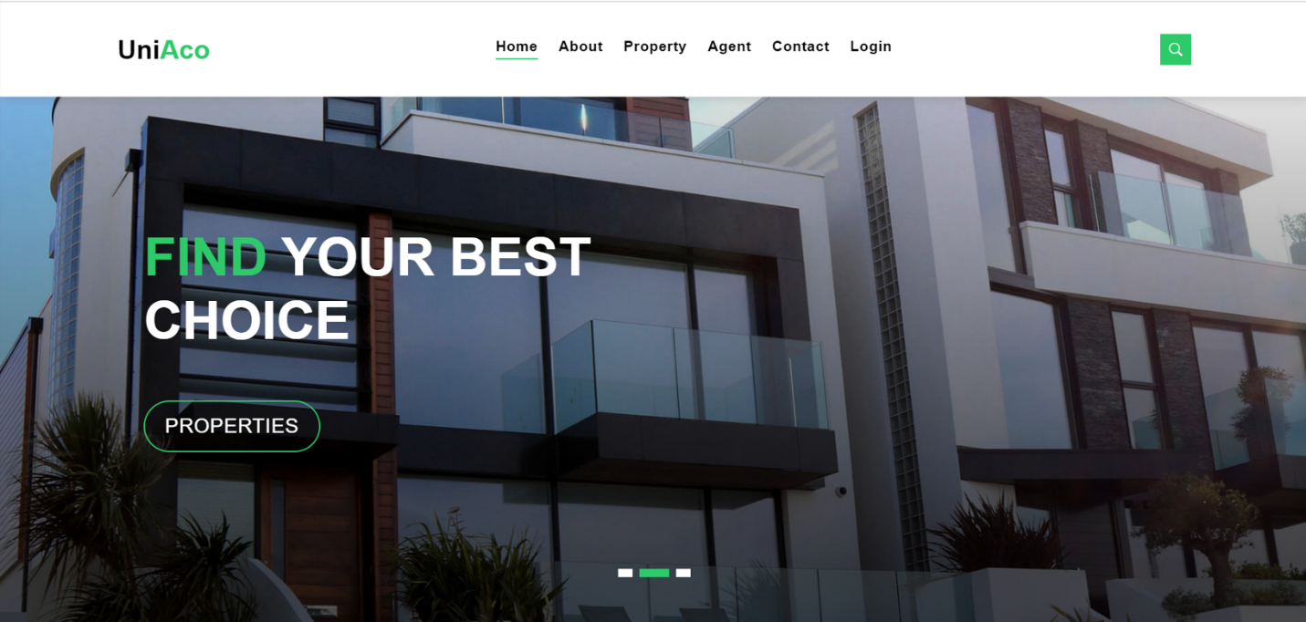

**Figure 3.2 Home Page**

**3.3 About Page**

Users can look about the website.

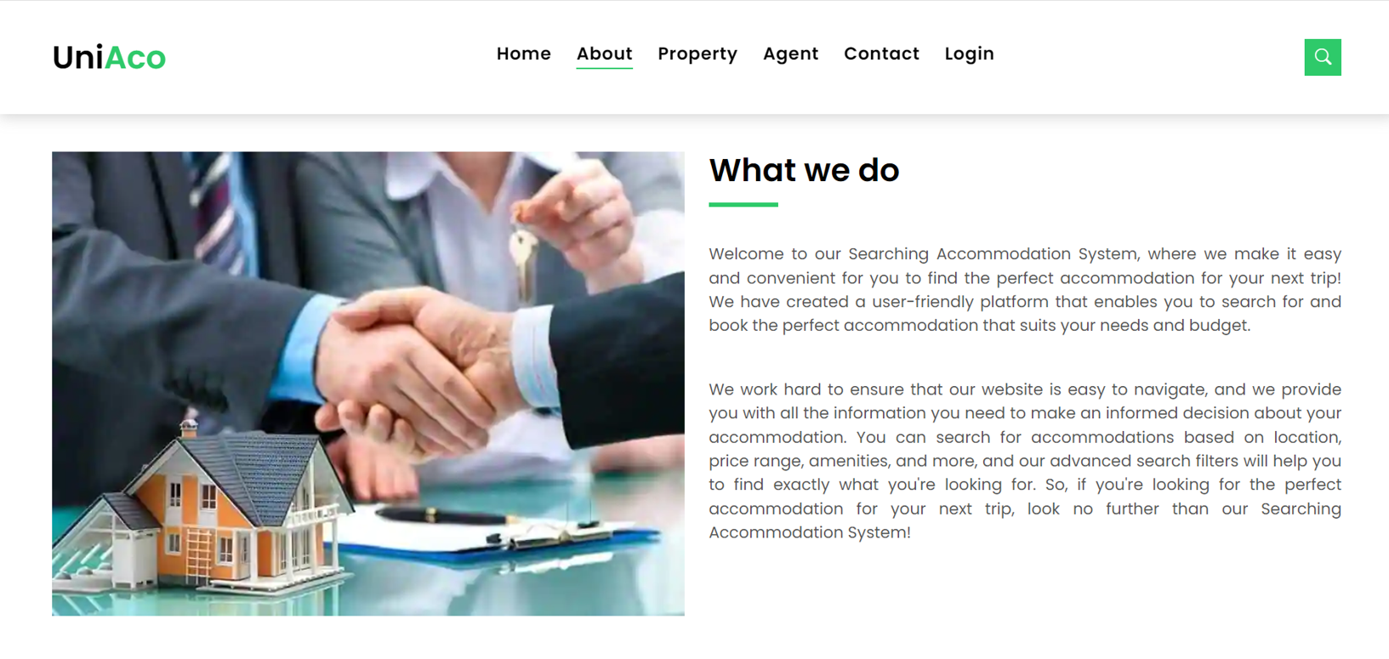

**Figure 3.3 About Page**

**3.4 Property Page**

Users can see the properties of accommodations.

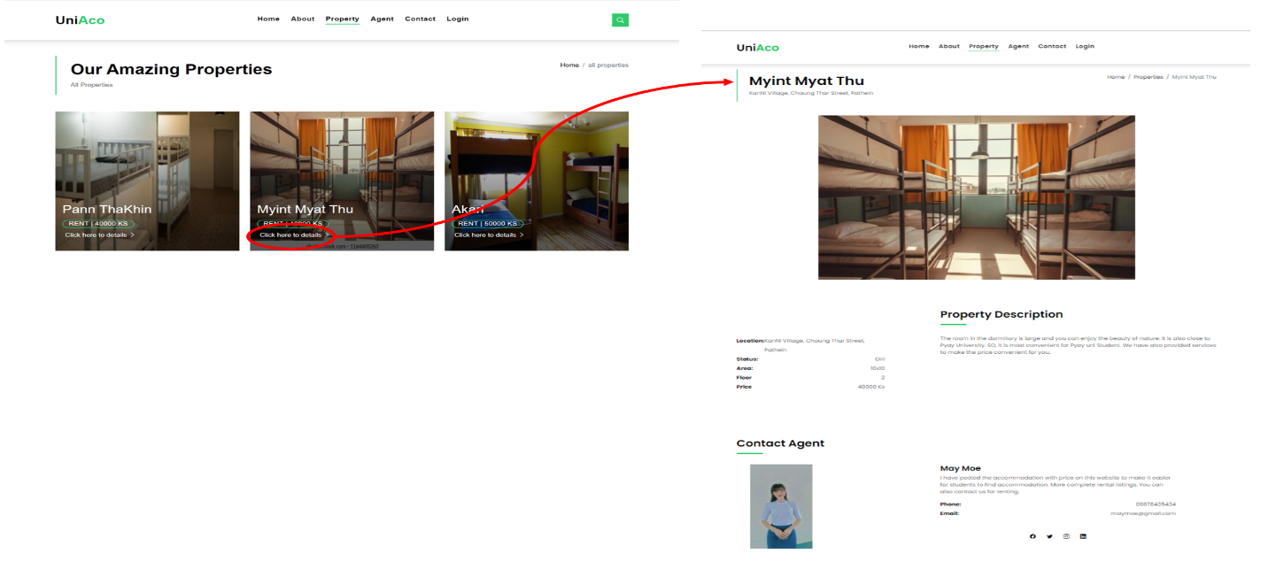

**Figure 3.4 Property Page**

**3.5 Agent Page**

Users can view agents’ details.

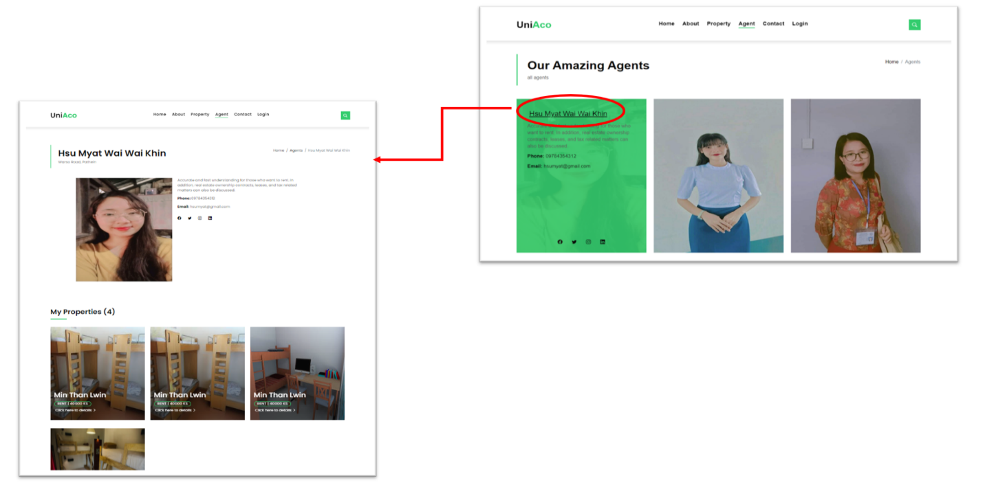

**Figure 3.5 Agent Page**

**3.6 Contact Page**

Users can contact the website by viewing this page.

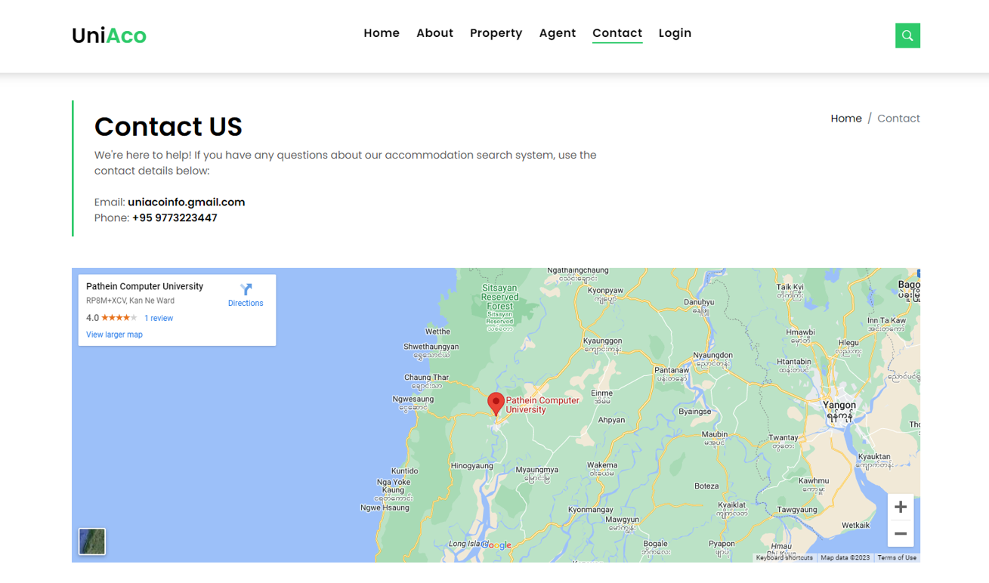

**Figure 3.6 Contact Page**

**3.7 Search Property**

Users can search the dormitory by typing location, status, price in the search bar.

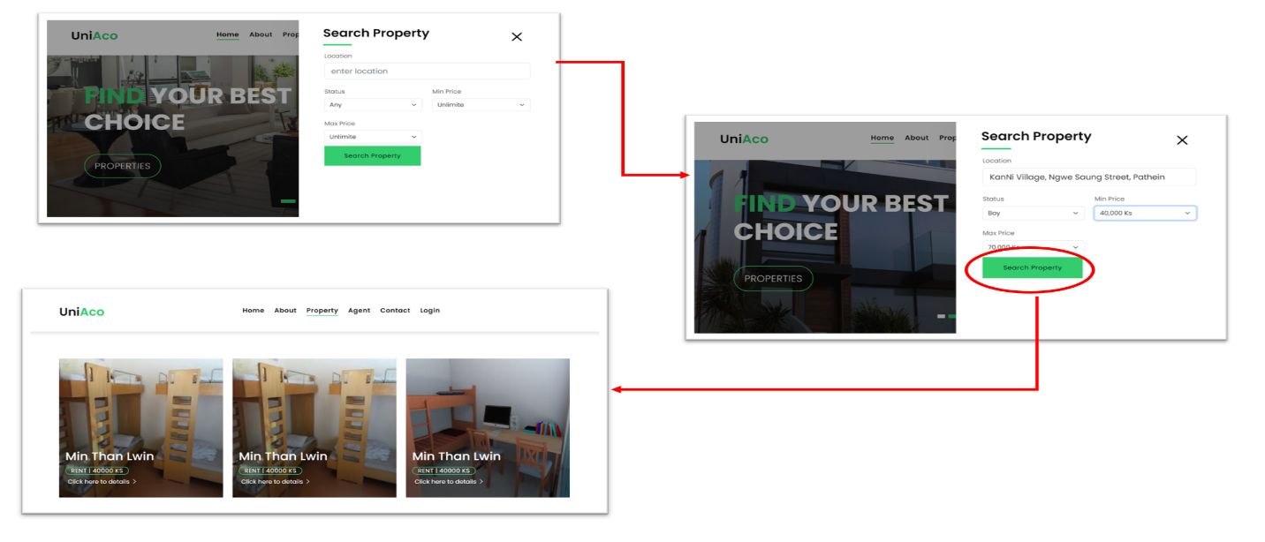

**Figure 3.7 Search Property**

**3.8 Agent Login**

Agent can enter email and password. If agent enter email and password correctly, accesses the agent dashboard.

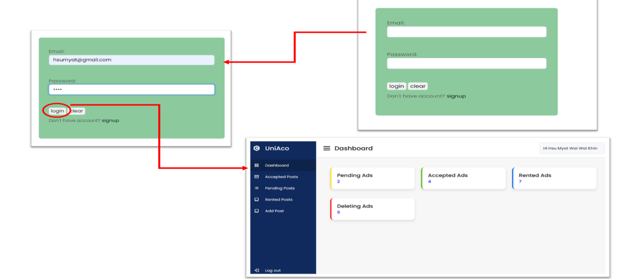

**Figure 3.8 Agent Login**

**3.9 Accepted Posts of the Agent**

Agent can view and edit the posts accepted by admin to advertise on the website. They can also confirm the rooms that have already been rented out by clicking ‘Rent’ button.

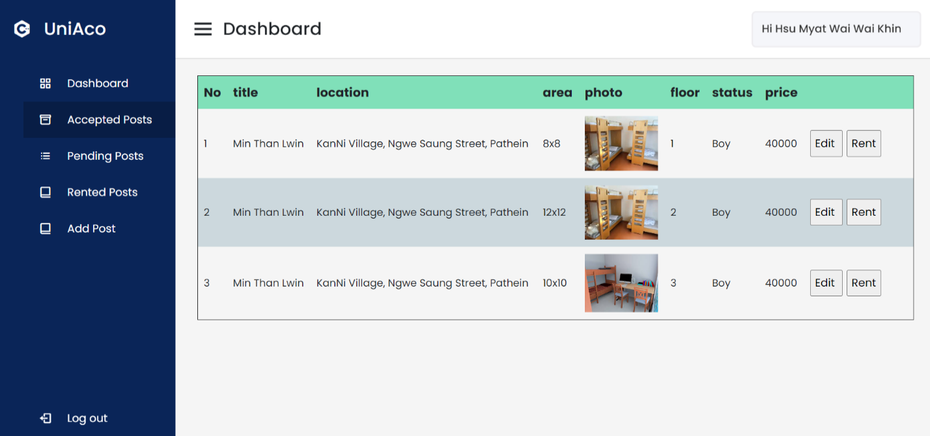

**Figure 3.9 Accepted Posts of the Agent**

**3.10 Pending Posts of the Agent**

Agent can view, edit and delete the posts that have been requested to the admin to advertise on the website.

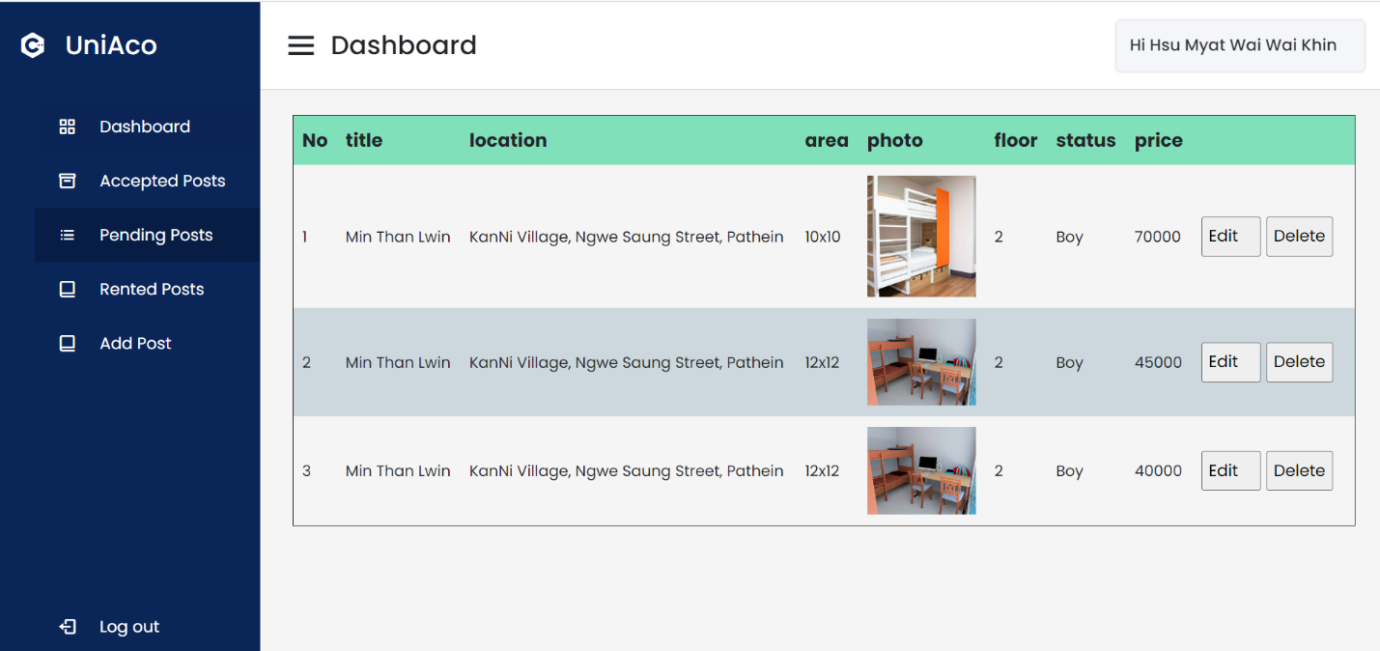

**Figure 3.10 Pending Posts of the Agent**

**3.11** **Rented Posts of the Agent**

Agent can view the rent out dormitories among the advertised dormitories.

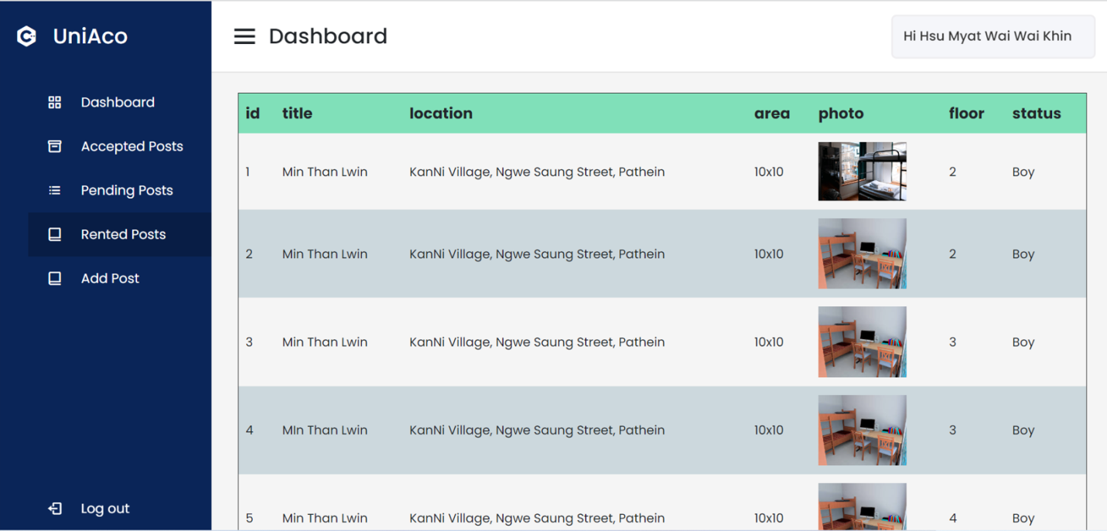

**Figure 3.11 Rented Posts of the Agent**

**3.12 Add Posts of the Agent**

Dormitory owners can post his advertise rooms for rent by filling the required information.

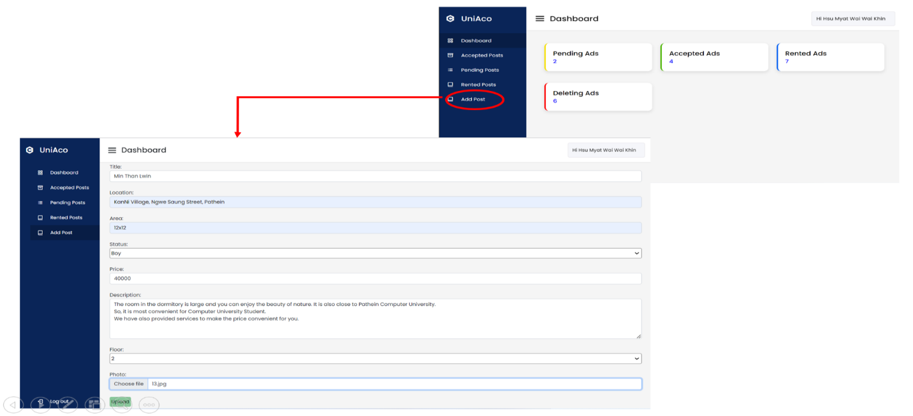

**Figure 3.12 Add Posts of the Agent**

**3.13 Admin Login**

Admin can enter username and password. If admin enter username and password correctly, accesses the admin dashboard.

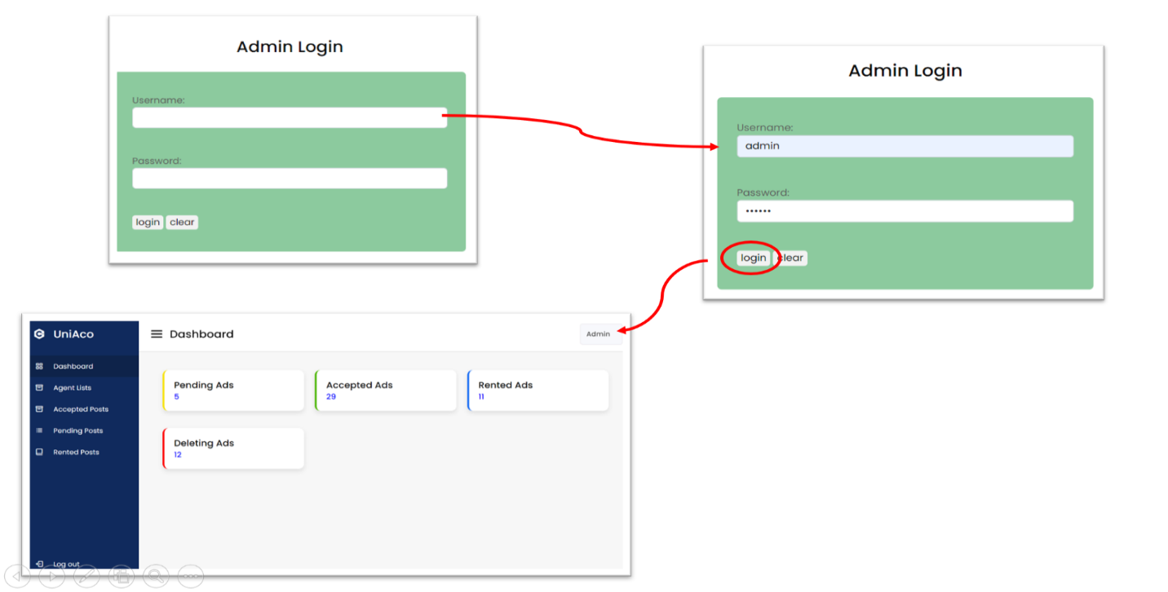

**Figure 3.13 Admin Login**

**3.14 Agent Lists of the Admin**

Admin can view, edit and delete the agent lists that registered in this website.

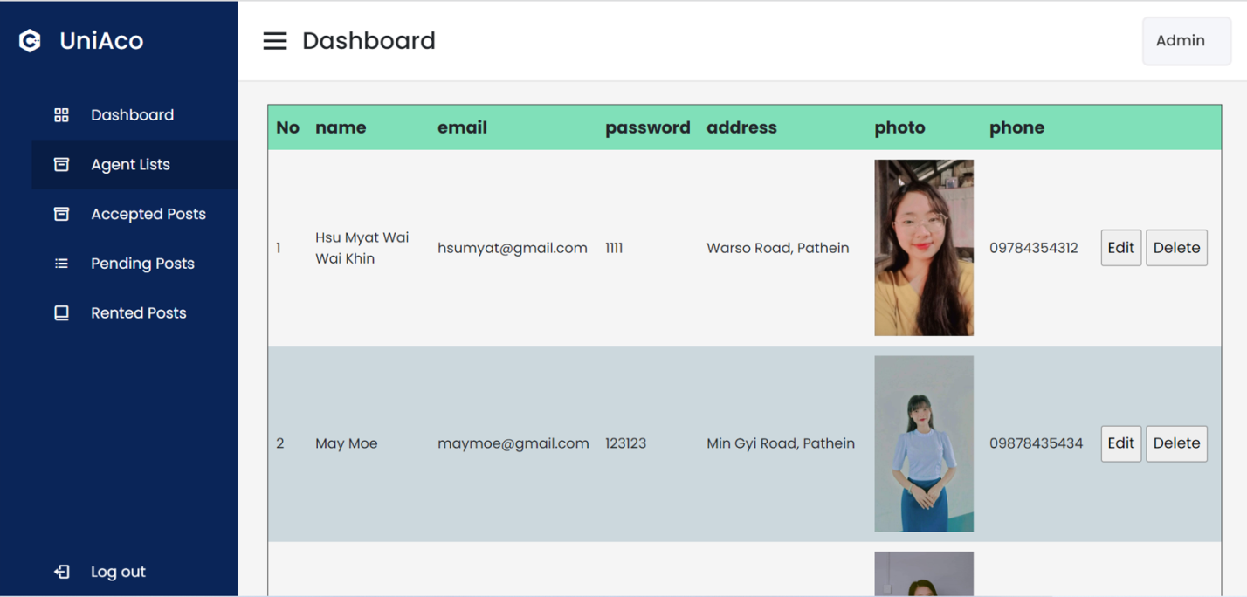

**Figure 3.14 Agent Lists of the Admin**

**3.15 Accepted Posts of the Admin**

Admin can view the posts that are allowed to be advertised on the website.

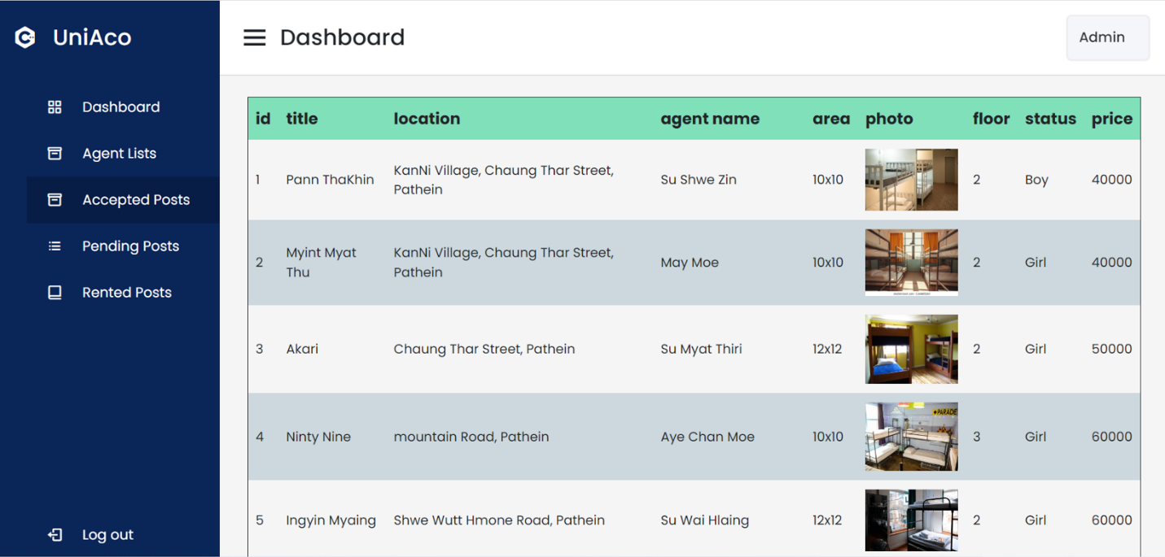

**Figure 3.15 Accepted Posts of the Admin**

**3.16 Pending Posts of the Admin**

Admin can view the details of posts and can decide whether or not to allow the advertise request by the dormitory owners.

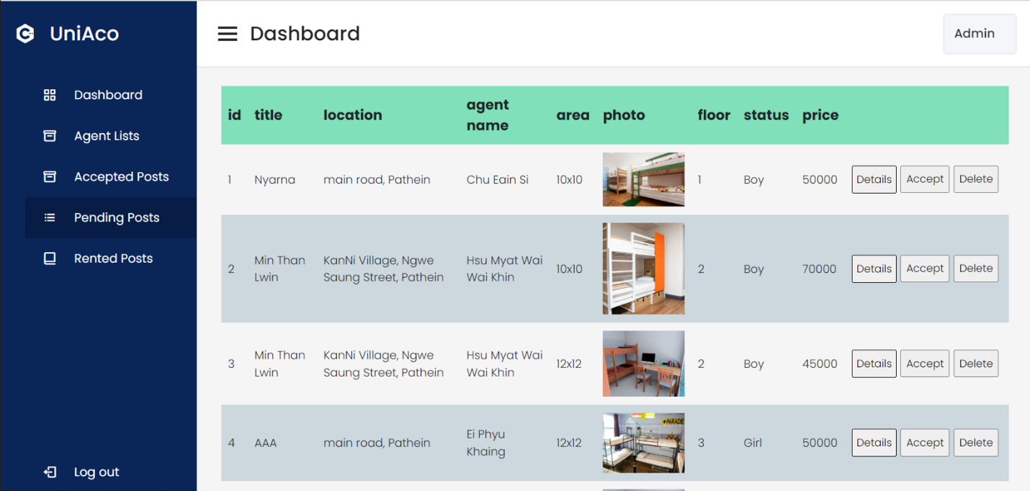

**Figure 3.16 Pending Posts of the Admin**

**3.17 Rented Posts of the Admin**

Admin can view the rent out dormitories among the advertised dormitories.

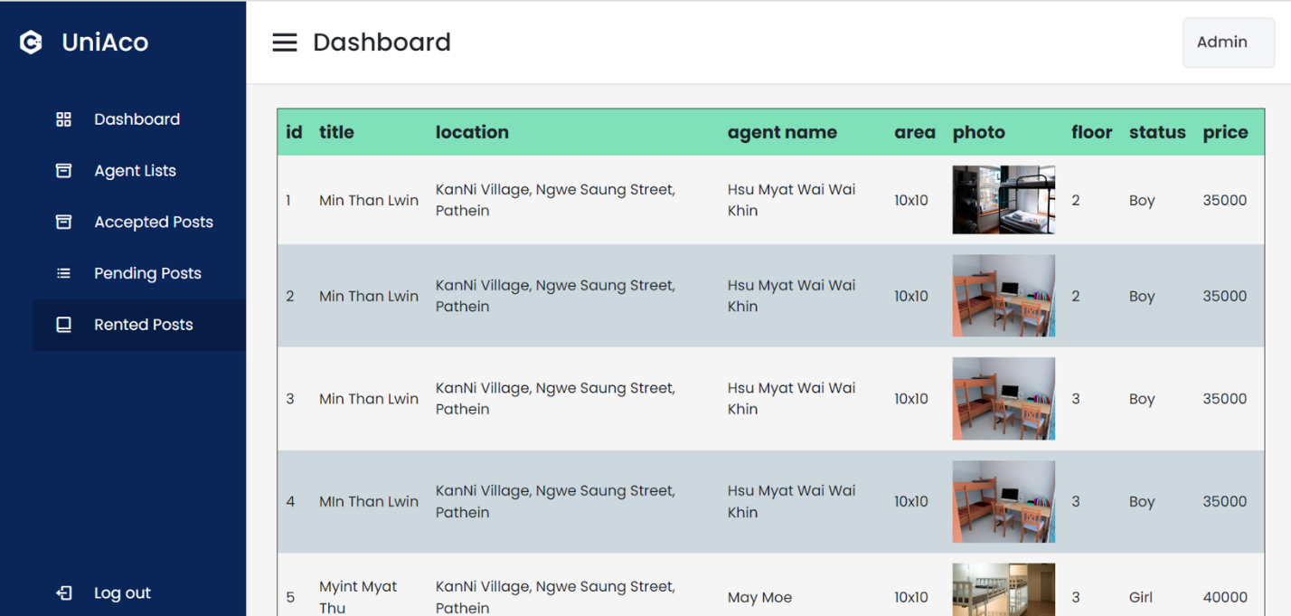

**Figure 3.17 Rented Posts of the Admin**

**Chapter-4**

**CONCLUSION**

This system provide Student Accommodation Search System for university students. Students can find the dormitories that are convenient without wasting time and effort. Dormitory finders can easily search the dormitory according to the price, location and status. Dormitory owner can quickly rent out the rooms in his dormitory by advertising on this website. With this platform developed, provide for user provide easy data flow, user pleasure and less hard work.

**4.1 Future Work**

We will add the payment section to the website. We will also add a dormitory booking for the dormitory finder and the feature to moake the responsive website for user to use easily.

**REFERENCES**

1. Beginning PHP 5.3 by Matt Doyle: [www.it.ebooks.info](http://www.it.ebooks.info/)
2. [www.w3schools.com](http://www.w3schools.com/)
3. [www.slideshare.net](http://www.slideshare.net/)